**Nile Rat Plasma Lipidomics – fasting vs. random**

**Objective**

**Project No. 0191**24 Aug 2021

**Project Lead:**Benton J. Anderson

**Project Contributors:**

Joshua J. Coon

Katherine A. Overmyer

Annie Jen

**Collaborators:**

Huishi Toh

Peng Jiang

James Thomson

**Acknowledgement:**

NIH P41 GM108538

Nile rats are a unique model system to explore incidence and biomarkers of diabetes due to their increased susceptibility to developing hyperglycemia when provided typical rodent chow diet during early development months (conception through weaning) vs. when provided a high-fiber rabbit chow diet in earlier development months. One of the challenges with Nile rats is that blood collections need to happen when animals are still quite young in order monitor diabetic progression and typical fasted-state blood collections could lead to increased stress in young animals. Random (non-fasted) blood sampling would be a better alternative, however, different postprandial states will likely drive higher metabolite variance in non-fasted samples.

This study aims to determine feasibility of random blood glucose-level sampling versus the standard fasted blood glucose sampling on diabetic Nile rats. The analysis presented here performed liquid chromatograph-mass spectrometry lipidomics on Nile rat plasma samples. Raw data were processed and subjected to preliminary data analysis.

**Results Summary**

**24 Aug 2021 Nile rat Lipidomics data.xlsx** contains 3 sheets of the same plasma lipidomics data at different stages of the filtering and normalization process.

The **Lipidomics raw** sheet of the document contains the raw output from the LipiDex/Compound Discoverer software workflow.

The **Lipidomics normalized** sheet contains the result of normalization on the filtered data. The median feature quantitation of each LC-MS file showed correlation to analytical run order, suggesting an instrumental sensitivity drift over time. To correct for this, we performed a normalization based on the coefficient of the linear regression for median feature quant per LC-MS file.

The **Lipidomics normalized filtered** sheet of the document contains the result of filtering the normalized data. Relative standard deviation (RSD) filtering was performed based on features with >50% RSD derived from the 2nd and 3rd quality control LC-MS runs (QC2 and QC3 files). Features were also filtered based on “Found in at least 4 files” to eliminate identifications found in relatively few files. LC-MS quality control files have been removed from the sheet, leaving only data used for quantification. Each lipid feature has been assigned a Unique Identifier. **We recommend using these data for analysis.**

**Explanation of column names:**

Unique Identifier: unique name for each lipid feature

Retention Time (min): Chromatographic retention time on liquid chromatography

Quant Ion: mass to charge (m/z) of ion used for deriving the quantitation value.

Polarity: Negative or positive mode polarity of the quant ion

Area (max): The maximum value found for integration of the quant ion over the chromatographic peak in all files.

Identification: Lipid molecule best identification based on all evidence.

Lipid Class: Lipid class abbreviation as defined at LipidMaps (<https://www.lipidmaps.org/data/classification/lipid_cns.html>)

Features Found: Number of files where MS2 library match was found.

File Names: 20210729_AJ_Toh_RatBloodGlucose_T1062M_20210325_8wk_RBG.raw (F10)

The name of each LC-MS raw file. **Note that (F10) does not refer to analytical run order.**

**Lipidomics Data Summary Figures**

**Figure 1:** Summary of boxplots of all lipid features from raw data per file, given in analytical order left-to-right. Y-axis gives log2 quantitation of features.

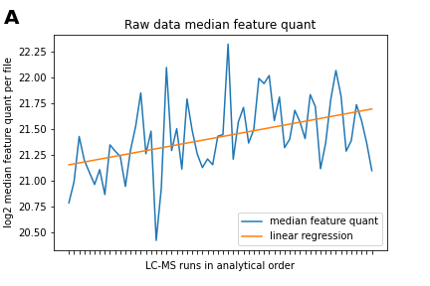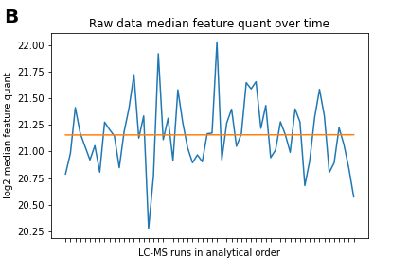

**Figure 2:** Median feature quant per file in analytical order in blue. Orange line is linear regression line fitted on median feature quant. **(A)** Median feature quant in analytical run order before normalization. **(B)** Median feature quant after normalization to linear regression line.

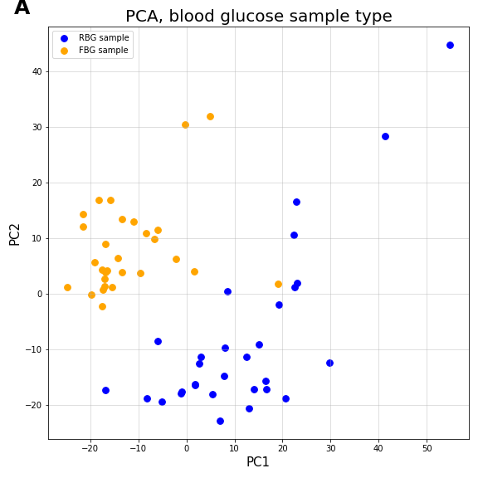

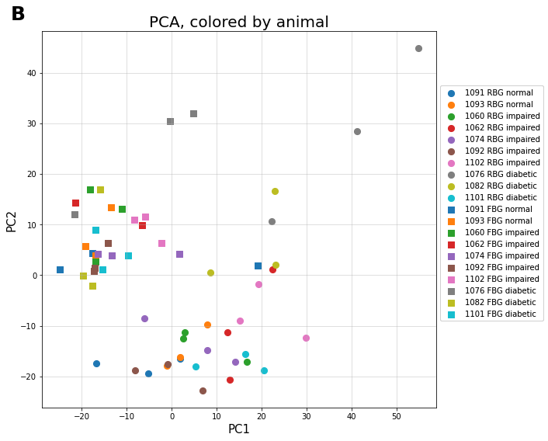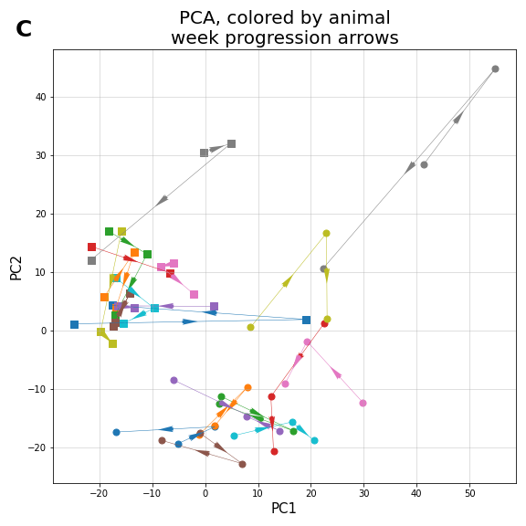

**Figure 3:** Principal component analysis (PCA) plots using normalized and filtered data of lipidomics features per file. **(A)** PCA of all 10 rats across all 6 weeks (60 samples total) showing separation of RBG vs FBG sample type. **(B)** The same underlying PCA plot, with points now colored by rat (10 rats total), with square markers corresponding to FBG, and circles to RBG. **(C)** PCA plot colored by animal, with arrows showing progression from week 8 to 9 to 10.

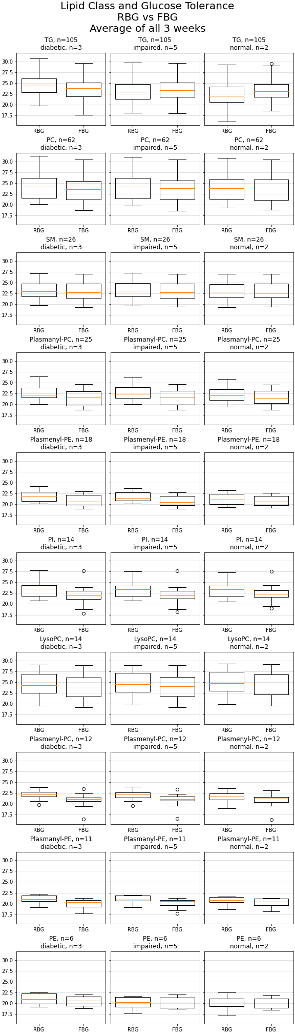

**Figure 4:** Comparing RBG vs. FBG, broken down by glucose tolerance in each rat in columns (n=3 diabetic, n=5 impaired, n=2 normal), and by top 9 most abundant lipid classes identified in samples in each row (abbreviations: TG: triacylglycerol, PC: phosphatidylcholine, SM: sphingomyelin, PE: phosphatidylethanolamine, PI: phosphatidylinositol). Each row maintains same log2 feature quant scale for comparison across lipid classes. Normalized data used.

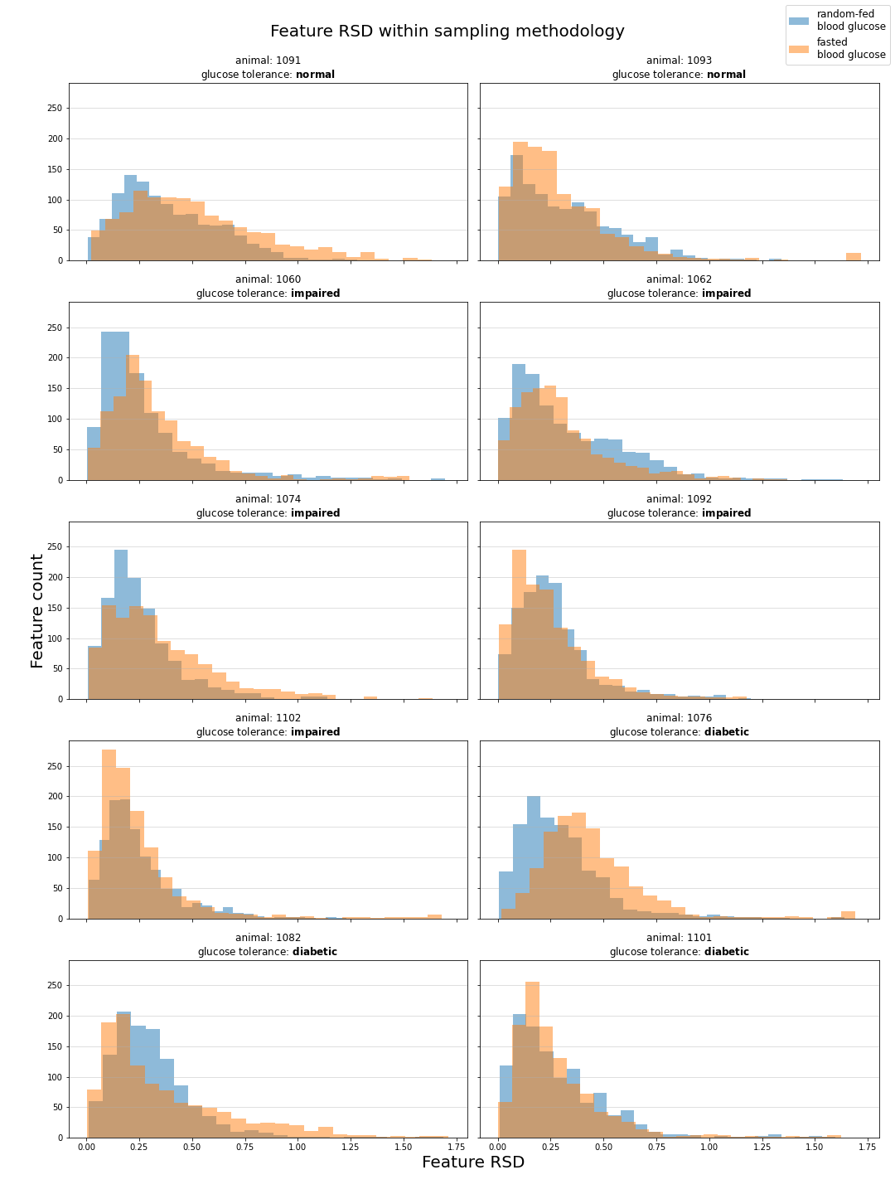

**Figure 5:** Comparison of feature RSD by blood glucose sampling method, separated by animal.

**Future Plans**

Parties will meet in September to discuss these results and other results shared in the interim. Ben and Katie will perform additional analysis of the LC-MS data in combination with the phenotypic observations of the Nile rats as given in the shared excel document that contains animal weights, FBG/RBG, and post-mortem tissue analysis. Katie aims to complete MS metabolomics experiments prior to next meeting. Ben will continue analyzing raw data and may share additional findings with collaborators.

**Sample Preparation**

**Lipidomics sample preparation:**

Plasma samples were removed from freezer and thawed on ice. Each sample was extracted with 500 uL 6:2:2 n-butanol:acetonitrile:water. Samples were vortexed for 10 s and then centrifuged at 14,000 x g for 2 min at 4 °C to precipitate protein. 100 uL of extract was dried down in an amber autosampler vial with glass insert by SpeedVac evaporator. For lipidomics, each extract was resuspended in 50 uL 9:1 MeOH:toluene then analyzed on mass spectrometer.

**LC-MS Analysis**

**LC-MS Lipidomics:**

Sample analysis was performed on an Acquity CSH C18 column held at 50 °C (100 mm x 2.1 mm x 1.7 μm particle size; Waters) using a Vanquish Binary Pump (400 μL/min flow rate; Thermo Scientific). Mobile phase A consisted of 10 mM ammonium acetate in ACN:H2O (70:30, v/v) containing 250 μL/L acetic acid. Mobile phase B consisted of 10 mM ammonium acetate in IPA:ACN (90:10, v/v) with the same additives. Mobile phase B was initially held at 2% for 2 min and then increased to 30% over 3 min. Mobile phase B was further increased to 50% over 1 min, then raised to 85% over 14 min, and finally raised to 99% over 1 min and held at 99 % for 7 min. The column was re-equilibrated with mobile phase B at 2% for 1.75 min before the next injection. 10 µL of extract was injected by a Vanquish Split Sampler HT autosampler (Thermo Scientific).

The LC system was coupled to a Q Exactive HF Orbitrap mass spectrometer through a heated electrospray ionization (HESI II) source (Thermo Scientific). Source conditions were as follow: HESI II and capillary temperature at 300 °C, sheath gas flow rate at 25 units, aux gas flow rate at 15 units, sweep gas flow rate at 5 units, spray voltage at |3.5 kV| for both positive and negative modes, and S-lens RF at 90.0 units. The MS was operated in a polarity switching mode acquiring positive and negative full MS and MS2 spectra (Top2) within the same injection. Acquisition parameters for full MS scans in both modes were 17,500 resolution, 1 × 106 automatic gain control (AGC) target, 100 ms ion accumulation time (max IT), and 200 to 1600 m/z scan range. MS2 scans in both modes were then performed at 17,500 resolution, 1 × 105 AGC target, 50 ms max IT, 1.0 m/z isolation window, stepped normalized collision energy (NCE) at 20, 30, 40, and a 10.0 s dynamic exclusion.

**Data Analysis**

**LC-MS Lipidomics:**

The resulting LC–MS data were processed using Compound Discoverer 3.1 (Thermo Scientific) in conjunction with LipiDex (1). All peaks with a 0.4 min to 21 min retention time and 100 Da to 5000 Da MS 1 precursor mass were aggregated into distinct chromatographic profiles (i.e., compound groups) using a 10-ppm mass and 0.2 min retention time tolerance. Profiles not reaching a minimum peak intensity of 5x105, a maximum peak-width of 0.25 min, a signal-to-noise (S/N) ratio of 1.5, and a 3-fold intensity increase over blanks were excluded from further processing. MS/MS spectra were searched against an in silico generated lipid spectral library comprising 35,000 unique molecular compositions from 48 lipid classes. Spectral matches with a dot product score greater than 500 and a reverse dot product score greater than 700 were retained for further analysis. Lipid MS/MS spectra which contained no significant interference (<75 %) from co-eluting isobaric lipids, eluted within a 3.5 median absolute retention time deviation (M.A.D. RT) of each other, and found within at least 2 processed files were then identified at the individual fatty acid substituent level of structural resolution. If individual fatty acid substituents were unresolved, then identifications were made with the sum of the fatty acid substituents. Normalization was performed using a linear regression of median peak intensity vs. analysis order (see Fig 2).

**References**

(1) Hutchins PJ, Russell JD, Coon JJ. LipiDex: An Integrated Software Package for High-Confidence Lipid Identification. *Cell Systems* **6**, 1-5 (2018). <https://doi.org/10.1016/j.cels.2018.03.011>